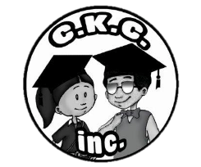
FAIR OAKS RECREATION CENTER
AND
COOL KIDS COMMITTEE, INC.
PRESENTS
“OPERATION GIVING BACK”
COMMUNITY EVENT

It’s that time of year again, and we would love to send a little holiday cheer your way! Since the holidays are fast approaching, we would love to delight families in the Fair Oaks Community, with gifts for their children this holiday season. You may only pre-register at Fair Oaks Rec Center.
IMPORTANT THINGS TO KEEP IN MIND

- You must pre-register to receive gifts / Age groups for gifts are newborn-12 years old.
- Pre-registration ends Friday Dec.8,2017
- The gifts are given on a first come first serve basis.
- NO same day registration will be accepted.
- Families must be present to receive gifts. (KIDS ALSO PRESENT)
- There will also be Arts & Crafts as well as games for the kids.
- Light refreshments and music
- Space is limited so REGISTER NOW!!!

DATE OF THE EVENT
December 23,2017
TIME OF EVENT
11:00am-1:30pm
LOCATION
Fair Oaks Recreation Center
1465 West Boot Rd. Ext
Marietta, GA. 30008
Phone: 770-528-4333 | Fax: 770-528-4332

